# USE CASE DIAGRAM

# SYSTEM DESIGN SPECIFICATION

## System Design:

**Use-Case Diagram**:

* **Use Case Diagram** shows the main actors of our system and their role in our management system. Here customer is the pivotal point where he or she sign up or log in by providing their personal information and looks for information about what they are looking for. Then they pay through their preferred method after finding their seeking object via information. Employees accept or deny their verification request and purchase request also updates user information. Manager often tests integrity and updates software also performs security check often. Accountants manages customer accounts and contacts bank for loan and transaction works also create bills. Technical support takes query from customer and solves software issues also and they frequently contact with the clients. Finally, advertisers advertise about new plot or flat that’s available and looks for new marketplace.
* **Actor**:

**Customer**: finds information, provides personal information, contacts client, do payment

**Manager**: manages overall company, controls security and applications integrity also update system as its required.

**Employee**: accepts or denies customer for doing transaction, verifies customer, updates user information.

**Accountant**: creates bills, contacts with the banks, manages user accounts

**Advertisers**: advertises about new plot or flat and rentals, also finds new marketplace.

**Technical** **Support**: contacts clients, takes query from clients, solves user’s software issues.

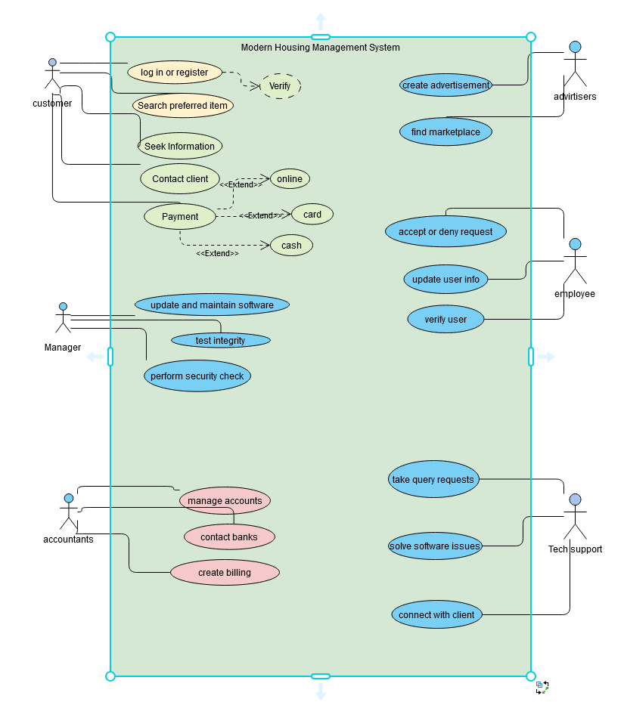

**Fig: Use Case Diagram**